**Ritesh Jain**

**Professional Summary**

* 13+ years of IT experience in creating / implementing vision, strategies, portals, business management, application development and for delivering business critical information systems to clients located in America, Africa & Asia Pacific regions.
* PMI-PMP certified having 5+ years of experience in IT Program, Projects and delivery management following
* DevOps, Agile, and waterfall approaches. A diverse background in technical and managerial areas.
* 4+ years of extensive experience as Solution Architect. Created end to end architecture for web, mobile and events driven applications under Digital Transformation.
* 10+ years of extensive experience in SOA, API, CEP, BPM and Analytics involving architecture, solution design, development and deployment.
* Experience in Pre-sales, Requirement Analysis, developing POCs and reply to RFP/RFI.
* Experience in Apache BigData software – Cassandra, Solr, Storm, Hadoop.
* Experience in Oracle Fusion 11g i.e. BPEL, OEM, and BAM, Oracle Service Bus 10g.

**Strength & Expertise**

Management: IT Program, Project, Delivery and Resource Management, Estimations. Functional: Banking - Finance, Supply Chain, Logistics, eCommerce, hi-tech and Hospitality. Technical: Solution and Application Architecture- API, SOA, CEP, BPM, Analytics, Web & Mobile.

**Day to Day**

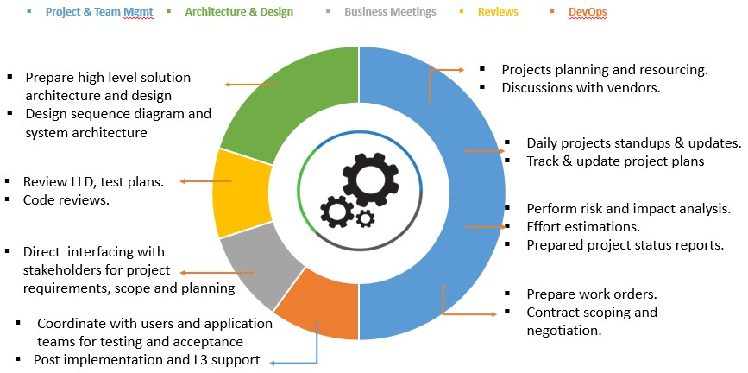

**Key Projects**

**Project # :** IT Delivery – Gaming & Hospitality

**Company :** Marina Bay Sands, Singapore

**Role :** Delivery Head, Solution Architect – SOA

**Description:** Managing multimillion dollars IT projects delivery under Digital Transformation program. Heading the team responsible for delivering innovating solutions by building web/mobile frontend, APIs, integration, event processing frameworks. Some examples are – Real time Casino Monitoring System, Loyalty Management System, Personalised Promotion & Offers Platform, CRM Mobile App etc.

Also managing BPM and IAM architecture and delivery stream. As a DevOps practices deliveries are being done progressively following Agile approach together with L3 support for existing applications.

**My Responsibilities:**

* Lead SOA delivery and manage up to 20 member team in onshore-offshore model.
* Prepare, review solution architecture and design for new applications / solutions.
* Program, Project planning, Budgeting, Contracting and Resourcing.

**Project # :** FPS & CONCORDE **Company :** L&T Infotech, Singapore **Customer :** Citi Bank.

**Role :** Solution Architect & Onsite Lead

**Description:** Lead the architecture and development of Faster Payment System (FPS) – A generic platform supports intra country real time payment transfer. Heading vendor team responsible for development and delivery of CONCORDE ESB platform. CONCORDE enables Citi bank to fulfil G3 payments mandated by MAS, Singapore. Application’s core processing engine is built using TIBCO BW, EMS and BE. CONCORDE also hosts 100+ various other interfaces needed by ICG ESB platform.

**My Responsibilities:**

* Discuss and analyse new product functional requirements from Stakeholders.
* Lead deliveries and manage 25 members development team in onshore-offshore model.
* Prepare Solution architecture, design and present the same to relevant Stakeholders.

**Project # :** Equinix Customer One (ECO) **Company :** Hitachi Consulting, Singapore **Customer :** Equinix Ltd.

**Role :** Application Architect.

**Description:** ECO is an enterprise level program to bring Equinix global operations on same platform. ECO includes various business entities i.e. customer master data, quote, order, finance, legal, asset, contract etc. TIBCO is used as an integration platform to integrate various boundary applications hosting said business entities. Total around 200+ interfaces were developed. Insight, an exhaustive monitoring and error handling solution also build to facilitate business users and IT teams to track data and take corrective action. BigData platform is used to store transaction data which is data source for Insight.

**My Responsibilities:**

* Discuss and analyse new product functional requirements from Stakeholders.
* Create architecture, solution design and present the same to relevant Stakeholders.
* Learnt Bigdata technologies, coordination with bigdata platform team as application owner.

**Project # :** Rates Management System

**Company :** Mindtree Ltd, Singapore

**Customer :** DBS Bank Ltd.

**Role :** Senior Consultant

**Description:** Developed a system which fetches market data for various rates (e.g. commodity, equality, currency etc) from various data provider (e.g. Bloomberg, Reuter etc). Further system applies business rules on these rates to calculate derived rates. At the end these rates gets inserted into a database to be available for various downstream systems (e.g Murex, Front Arena etc).

**My Responsibilities:**

* **Product management, agile project planning, delivery and team management** together with **functional- technical design.**
* Requirement discussion with business users, develop POCs and response to RFP/RFI.

**Project # : NGN- Pinless Recharge Company :** TIBCO Software (I) PVT Ltd. **Customer :** Telkom SA Ltd. SA

**Role :** Architect, BWSE-BW SME

**Description:** Design, development of an end to end solution for validate/recharge of Telkom product – Prepaid Mobile, Fixed Landline and World Call Card. The business process was developed in TIBCO BW and then migrated into TIBCO BWSE. AMX-BPM was used for workflows e.g. validation work-item, prepaid or calling card activation etc.

**My Responsibilities:**

* Went **onsite (Pretoria, SA)** for requirement gathering, POCs and architecture design.
* **Pilot project having 13 services was implemented** in two weeks and pushed into testing.

**Project # : Tibco to Oracle Fusion Migration**

**Company :** Tata Consultancy services Ltd. **Customer :** Agilent Technologies, USA **Role :** Module Lead

**Description:** To reduce the Tibco product licence cost, client has taken the decision to migrate the whole middleware environment from Tibco to Oracle technology i.e. Oracle Fusion 11g and Oracle service bus 10.3.1. All the 59 interfaces/ 112 flow are being migrating on OSB/BPEL Migration also include to use of various ERP adapters like SAP, Siebel etc. JMS as well as http are being used as transport protocol. OEM, Grid control, BAM and log files are being used for the transaction monitoring and health check.

**My Responsibilities:**

* Migration of interfaces from **TIBCO to Oracle Fusion**.
* Explore **Oracle BAM** and build a robust **logging and tracking portal**.

**Project # : TIBCO NG Quote Development & AMS Project**

**Company :** Tata Consultancy services Ltd. **Customer :** Agilent Technologies, USA **Role :** Sr. Developer

**Description:** This project involves development of a new interface for the online quote creation. The interface design consist request-reply flow between A.Com (web application) and ERP. Designed interface receives the quote request by SOAP web service and apply some typical business logics. Further by JDBC procedure, it creates the quote in ERP and then corresponding response send to requester again by SOAP web service.

AMS project involves the Production Support and Maintenance of already running applications in TIBCO environment. There are total 55 Tibco interfaces, which transfer the data between various boundary applications in their desired format

**My Responsibilities:**

* **Independently handled project** from the requirement gathering to development and prod Go-Live.
* Got the **CSI five out of five** (5/5) and also got **TCS-Gems award** for the outstanding success of the project

**Education Qualification**

B.Tech – Electrical Engineering - Governament Engineering College ,India